Title of Section: Projects in the Making

Text:

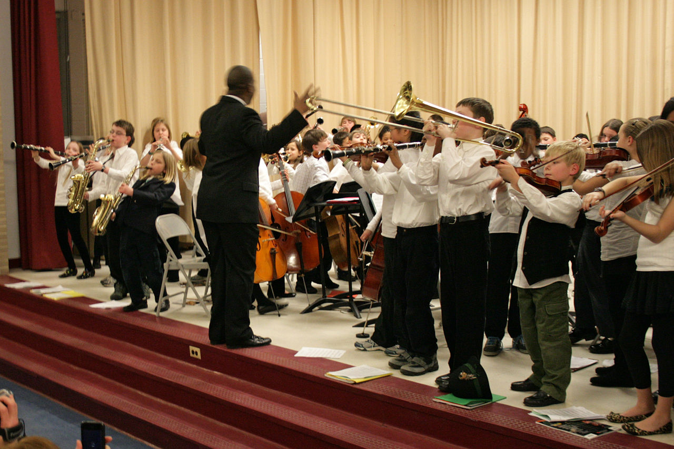**Recitals and Concerts**

Phyo loved music, especially musicals and silly songs with a catchy tune. Whether in the hallway during study breaks or on top of a mountain during a weekend hike, he was never shy about sharing his cheerful, bold, and melodic voice with the group. With this spirit, PN2K has been reaching out to both individual performers and local Burmese groups to explore the possibility of future musical escapades. Please stay tuned for more details!

**Tanuki Gifts**

Gifts to spread joy and cheer, all with a tanuki (raccoon dog) theme. Why tanuki? It started out as a running joke during Phyo’s freshman year that the tanuki was his brethren animal spirit. Indeed, it became his unofficial animal mascot by the time he graduated from MIT. Designs are currently under development.

